Once you have informed the Club Welfare Officer (Jono Ewen, jonoewen@gmail.com, phone:07714 282 591) of your name and contact detail, please follow these instructions to obtain your British Rowing DBS clearance (previously known as CRB clearance.)

Go to the following website: https://www.britishrowing.org/about-us/policies-guidance/safeguarding/guidance-documents/

How to Obtain DBS Clearance

Click on the link for “WG 2.6” under Section 2.

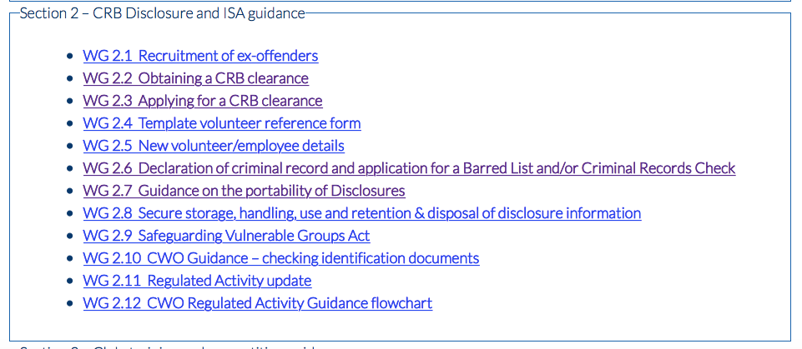
This will then take you to the screen below.

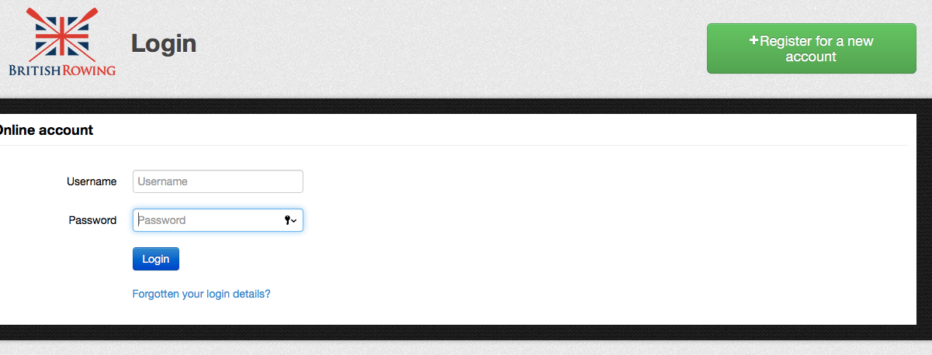

You will need to have a British Rowing online account – this is free and requires you to register for it. Click on the right hand green button.

This will take you to the registration form (shown on the next page) – complete and create your online account with password.
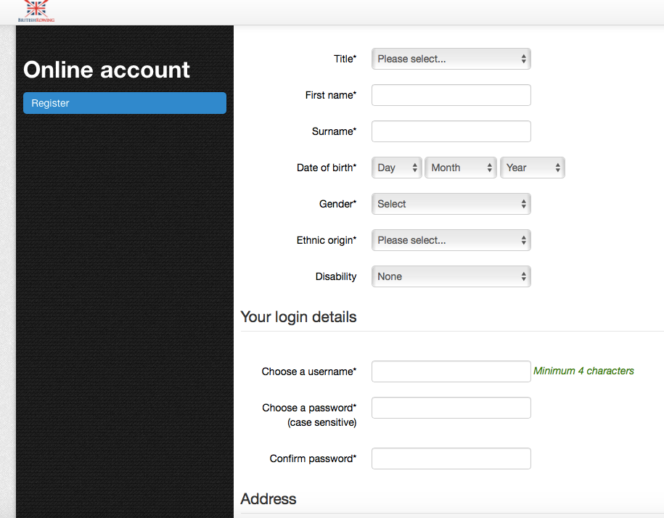

After completing registration you will be able to complete the electronic WG 2.6 form (shown above).

Once this form has been completed, British Rowing will inform me (Jono Ewen) that I am allowed to enable TMG (the sub-contracted DBS clearance company) to electronically (through your email address) invite you to complete your DBS form online.

Next Steps:  - Open electronic invitation email from TMG.  - Complete all sections of the online form. (guidance notes are available on the TMG website if needed.)  - Show me (in person) your identification documents, (3 documents, at least one showing proof of address.)  - I (Jono Ewen) will submit verification of your documents and identity.  - Your application form will be submitted to the DBS. | Please note:  - It is not possible for me to re-send electronic invitation emails, so please check your spam folders to sure you have it.  - Each applicant needs their own email address. A joint email address cannot be used for a husband and wife/partners as the contact for the TMG invitation to complete the online application form.  - You must complete your online application within 60 days as if it is inactive for any longer it will automatically close and be withdrawn.

If you have any queries please contact me:
Jono Ewen
Welfare Officer, Hexham Rowing Club
jonoewen@gmail.com
07714 282 591

